SAP UI-Create Goods Movement

General

|  |  |
| --- | --- |
| Type of Object | **Interface** |
| **Description** | Create gateway service which will create Material Document for Transfer Posting |
| **Process** | P2P |
| **Sub Process** | N/A |

DOCUMENT ORIGIN

|  |  |
| --- | --- |
| AUTHOR | OPERATION UNIT |
| Souvik Bhattacharya | SAP – APPS TWO |
|  |  |

CHANGE HISTORY

|  |  |  |
| --- | --- | --- |
| VERSION | DATE | CHANGES |
| 1.0 | 26-AUG-2016 | Initial version |
|  |  |  |
|  |  |  |
|  |  |  |
|  |  |  |

REVIEW AND APPROVAL

|  |  |  |  |  |
| --- | --- | --- | --- | --- |
| COMPANY | NAME | ROLE | DATE | SIGNATURE |
| Capgemini India Pvt. Ltd. | Suprio Chatterjee | Mentor | 26-AUG-2016 | Suprio Chatterjee |
|  |  |  |  |  |
|  |  |  |  |  |
|  |  |  |  |  |
|  |  |  |  |  |

# Introduction

## Document Purpose

This document tells how to create sap gateway service which will create the Material Document for Transfer Posting to transfer Stock from one storage location to another storage location.

# MAJOR FEATURES

Here, this document shows how to create sap gateway service which will create the Material Document for Transfer Posting to transfer Stock from one storage location to another storage location.

The whole process is described with step by step screenshot.

# TECHNICAL DETAILs:

## [Step](http://help.sap.com/saphelp_ewm70/helpdata/en/74/d67237902ae147e10000009b38f842/content.htm) by Step process to create Gateway service

**Step-1:** Create RFC function Module which will create the Material Document. This function module will be called inside the gateway service to create the Material Document.

Below is the code of the RFC Function Module



**Step-2**

Go to Transaction code **SEGW** to open the Gateway Service Builder

**Step-3**

Click on the **Create project** button

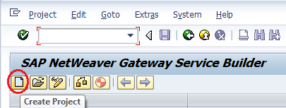

**Step-4**

Enter the **project name** and **description** and click on the **continue** button

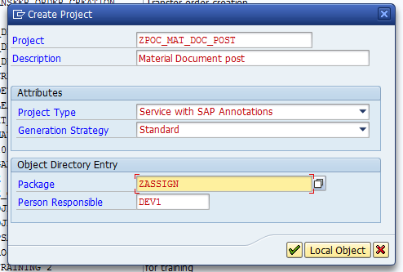

**Step-5**

Right click on the ‘**Data Model’** and click on the menu ‘**Import🡪 DDIC Structure’** to create Entity Type and Entity Set by referring the DDIC structure

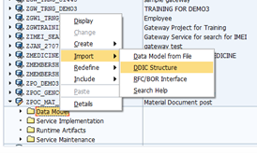

One popup wizard will open where enter the ‘**Entity type name’** and the DDIC structure name.

Here first create one entity type for the Material Document header info which will be passes to the RFC Function Module as importing parameter as Material Document header

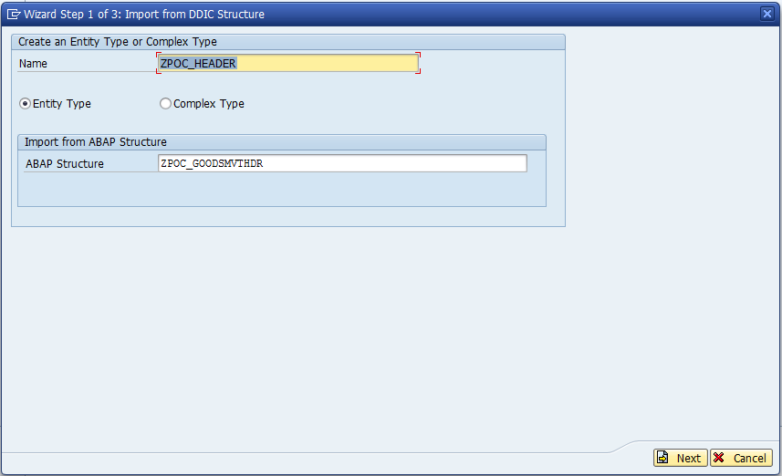

Choose the structure’s field name which are needed in the gateway for Material Document header to pass the value

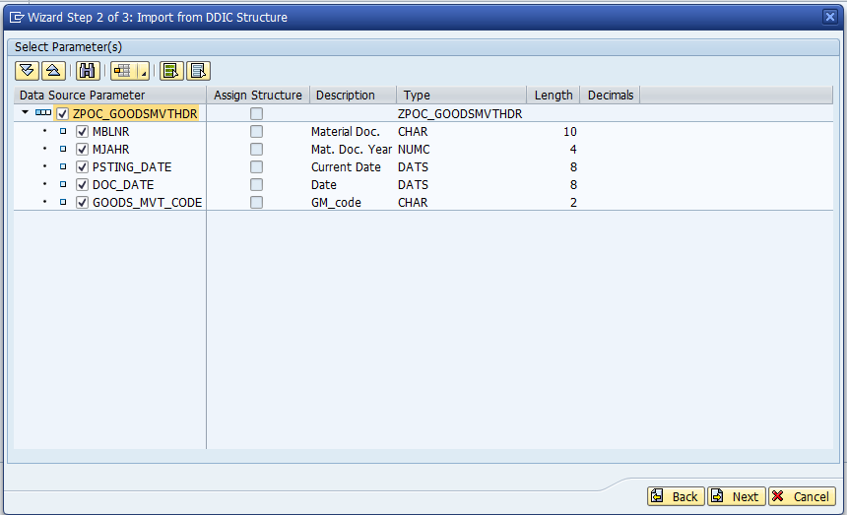

Select the key field check box

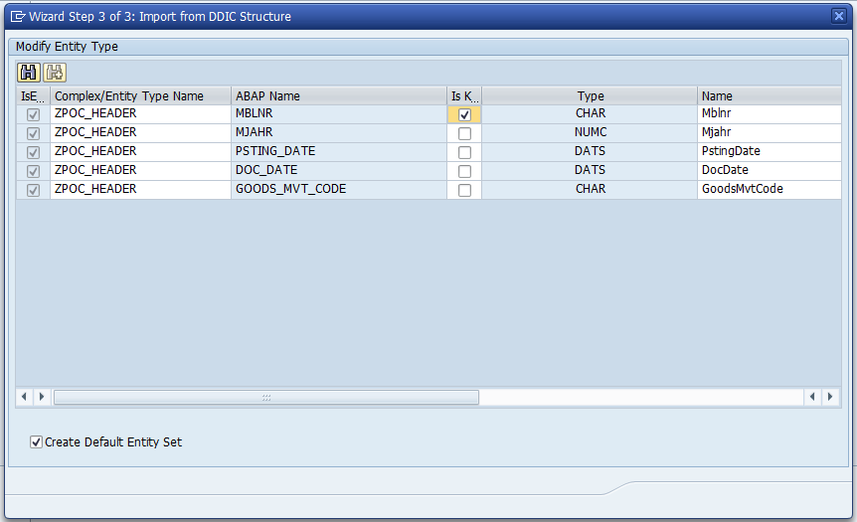

Make the date fields posting date and Document date as Nullable.

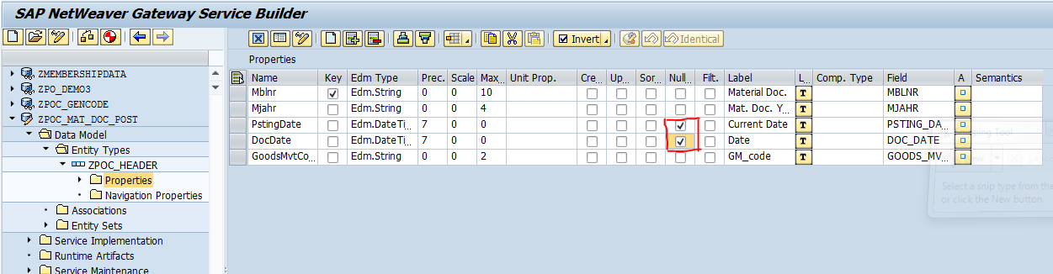

Follow the above process to create entity for Material Document Item

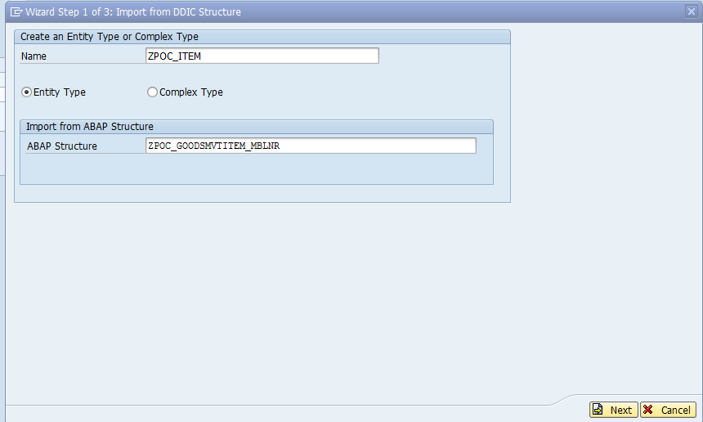

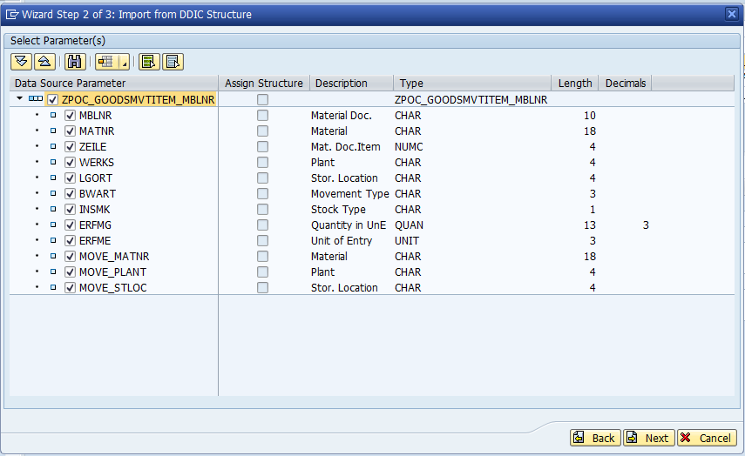

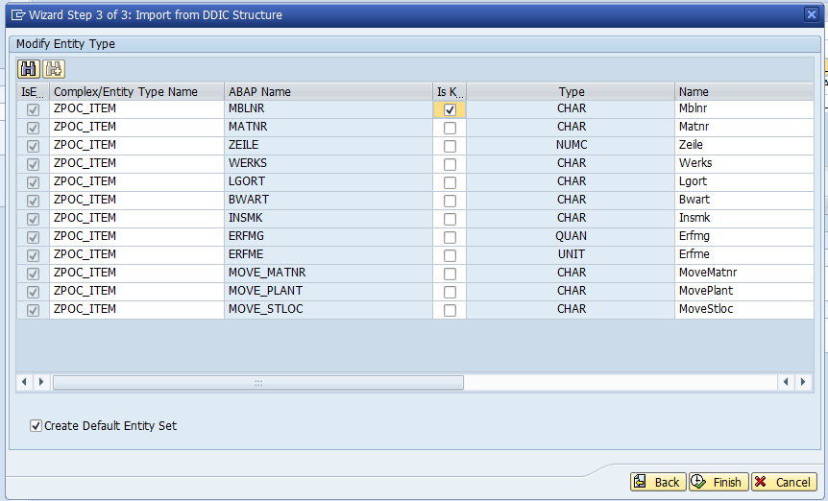

**Step-6**

After creation of Header entity and Item entity **Right Click** on the ‘**Association’** and choose ‘**Create’** to create the association.

Here by creating association we are establishing the relationship between the Header entity set and Item entity set

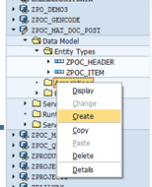

Enter the association name, cardinality and the navigation property name which will automatically create the navigation link between Header entity and Item entity.

Here the cardinality for the Header is ‘1’ and for line item it is ‘1:N’.

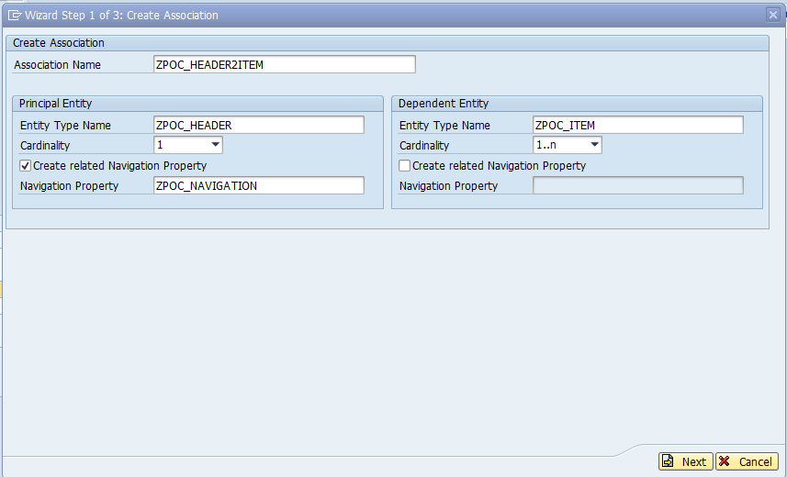

Enter the referential constraint field in the next screen

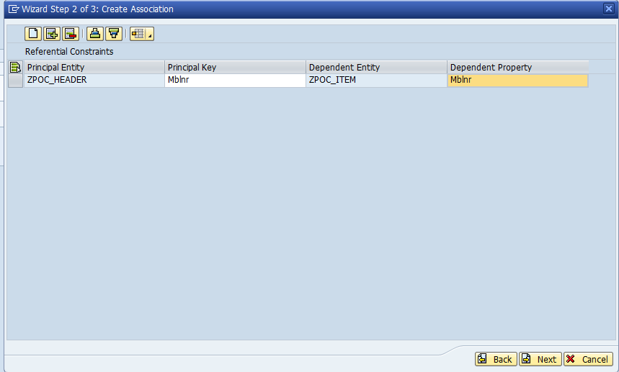

Association will be created as below

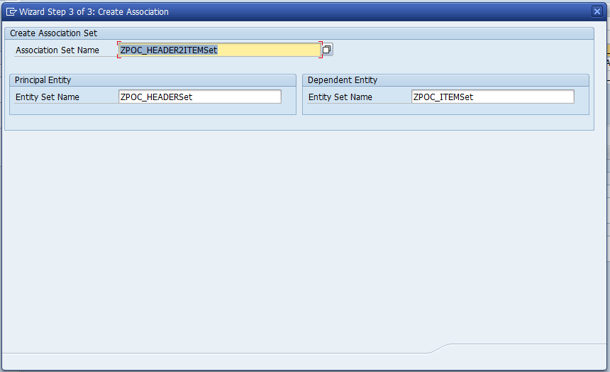

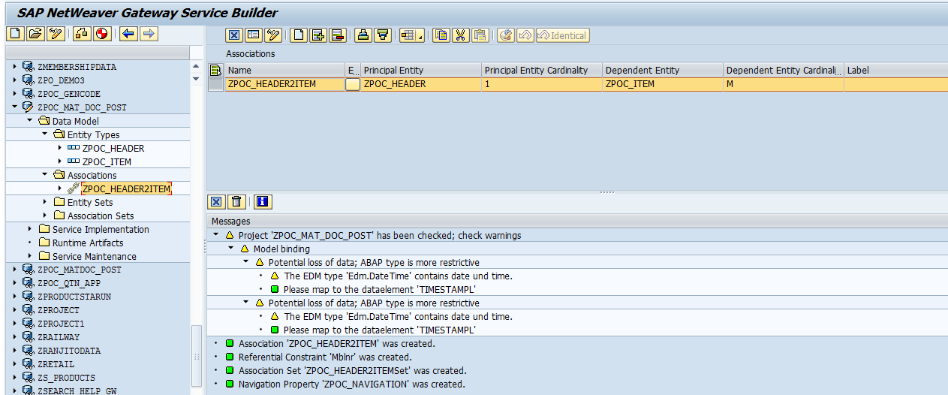

Navigation Property was also created.

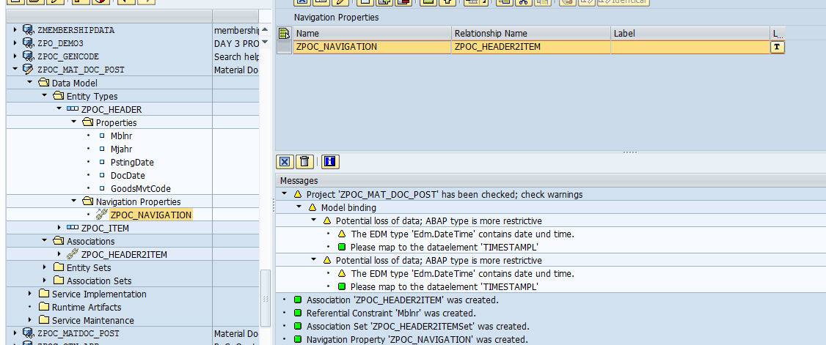

**Step-7**

Now click on the ‘Generate Runtime Services’  button to generate the service

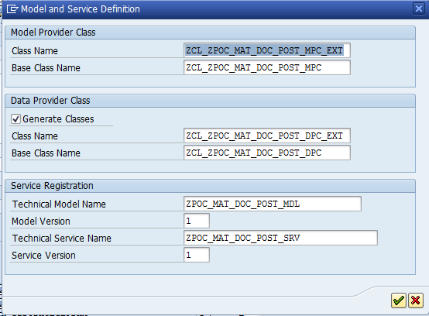

Runtime artifacts were created successfully.

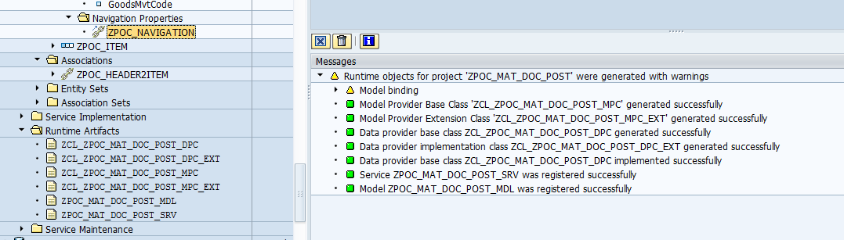

**Step-8**

Now expand the **‘Runtime Artifacts’** and **right click** on the data provider class extension and choose **‘Go to ABAP Workbench’** to implement the code in the data provider extension class.

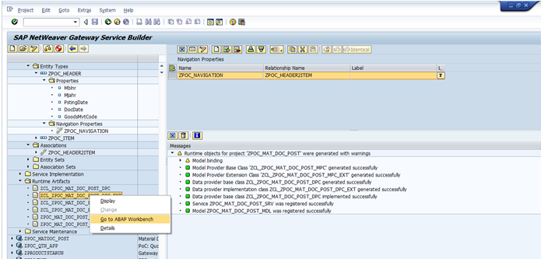

Here, in the **data provider class extension** expand the methods and **redefine** the method **‘CREATE_DEEP_ENTITY’**

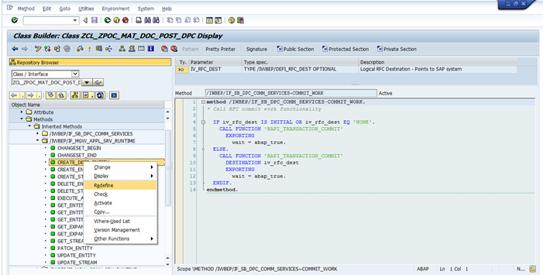

**Step-9**

Here, inside the method ‘CREATE_DEEP_ENTITY’ follow the below steps

**First Step:** **Create a deep structure** variable to get the data in header with item as described in the association

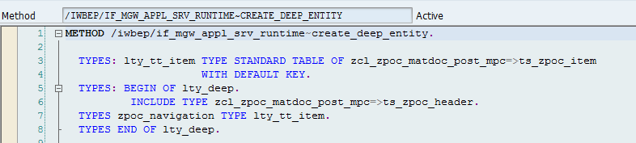

**Second Step:** **Read the incoming data** (Header + Item) **into the deep structure** by using the method ‘READ_ENTRY_DATA’ of ‘IO_DATA_PROVIDER’ parameter.

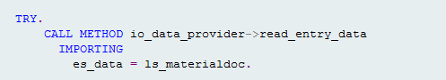

**Third Step:** **Process the data** for the RFC function module which will create the material document.

**Fourth Step:** **Call the RFC function module**.

**Fifth Step:** After successfully creation of Material Document by the function module **send the Material Document number to the gateway response** by using the method ‘COPY_DATA_TO_REF’

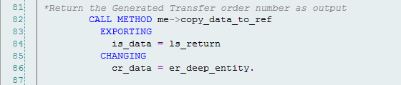

**Sixth Step:** Create LOG from the return of the RFC call.

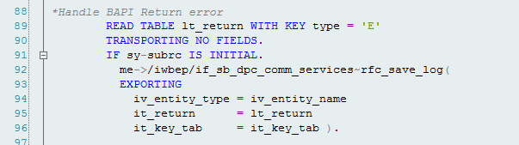

Code snippet from the Deep entity of the Service:



**Step-10**

Expand the ‘**Service Maintenance’** and Double click on the ‘LOCAL’ and click on the ‘**Register’** button  and enter the system where to register and run the Gateway service

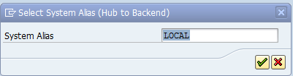

Enter the **package name** and click on the **continue** button

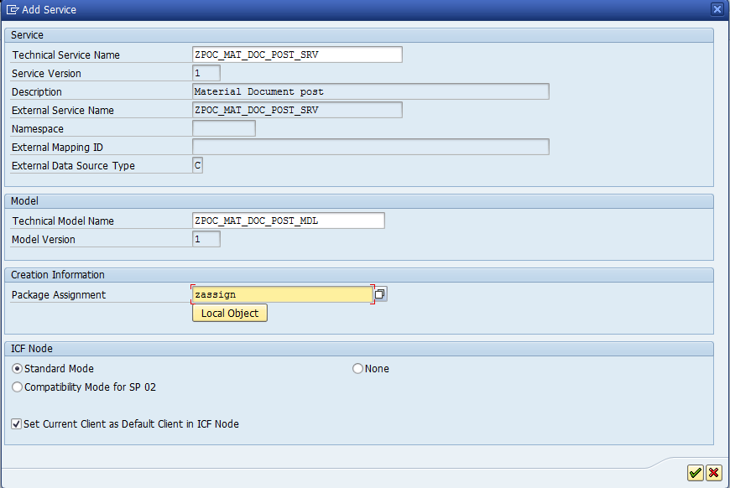

**Step-11**

Now click on the  ‘Maintain’ button to test the gateway service and get the URI of the service

One popup will appear there choose the ‘Yes’ button

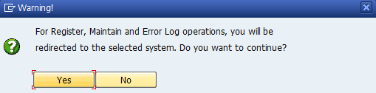

Now click on the ‘Gateway Client’ button 

**Step-12**

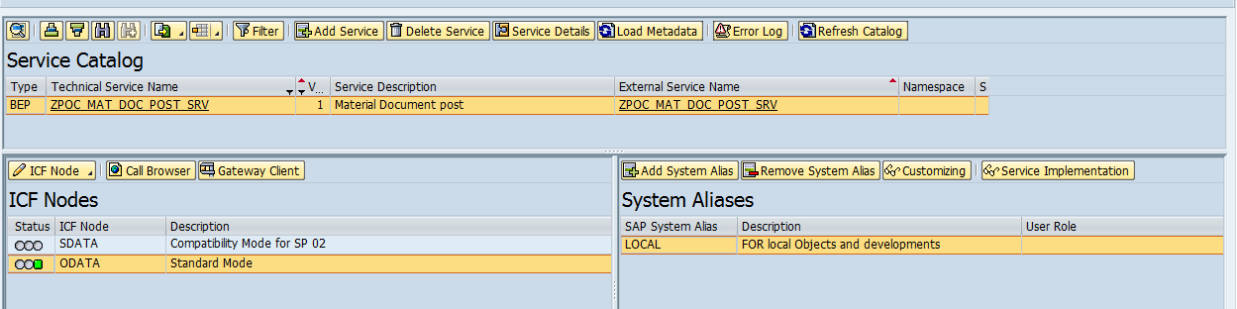

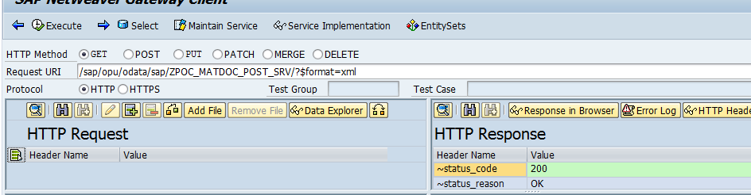

**Change the URI and Radio Button to ‘POST’**: change the URI as below and enter the Payload data for testing and choose the radio button as ‘POST’ to test the gateway service as below:

**URI: /sap/opu/odata/sap/ZPOC_MAT_DOC_POST_SRV/ZPOC_HEADERSet**

Where **ZPOC_HEADERSet** is the Header entity set name

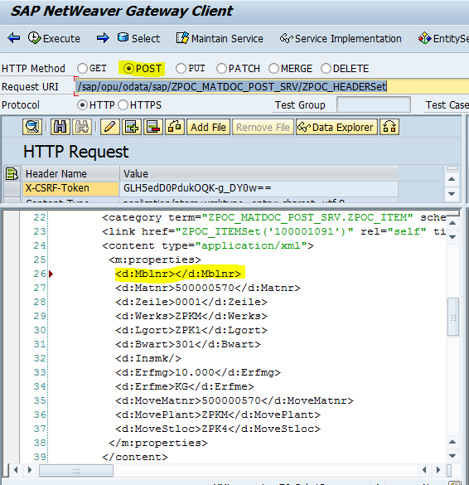

The response returns back with the new created Material Document number as shown below

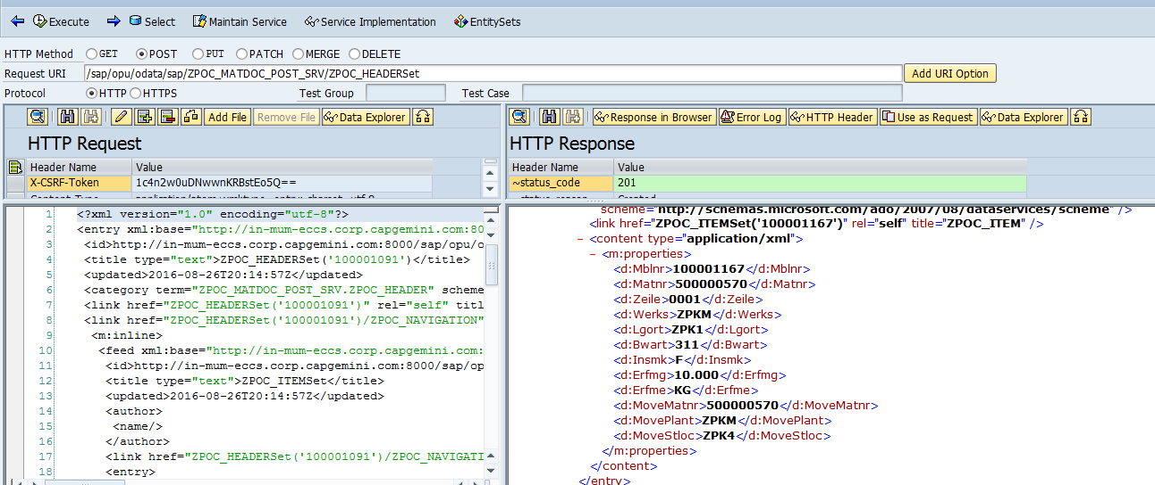

Here, the Material Document 100001167 generated.

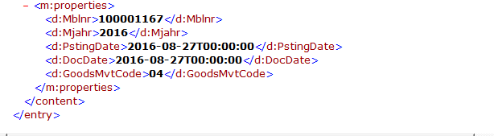

From MB03 the Material Document can be viewed.

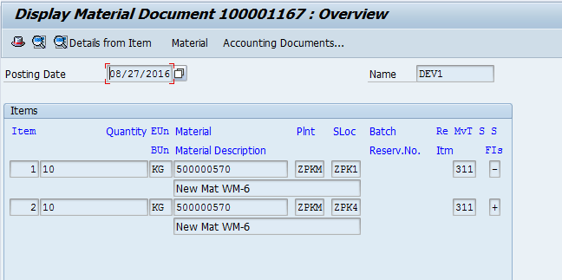

# UNIT TEST CASE

As mentioned above